**TASK 9**

Directory Operations in C

Use system calls to list all files and directories in the current working directory.

Change the current working directory to "/tmp".

Create a new directory named "testdir" within "/tmp" and set its permissions to 755.

**CODE –**

#include <stdio.h>

#include <stdlib.h>

#include <dirent.h>

#include <unistd.h>

#include <sys/stat.h>

int main() {

DIR *dir;

struct dirent *entry;

char cwd[1024];

// Get and print current directory

if (getcwd(cwd, sizeof(cwd)) != NULL) {

printf("Current directory: %s\n", cwd);

} else {

perror("getcwd error");

return 1;

}

// Open current directory

dir = opendir(".");

if (dir == NULL) {

perror("opendir error");

return 1;

}

// List files and directories

printf("Listing files:\n");

while ((entry = readdir(dir)) != NULL) {

printf(" - %s\n", entry->d_name);

}

closedir(dir);

// Change directory to /tmp

if (chdir("/tmp") != 0) {

perror("chdir error");

return 1;

}

printf("Changed to /tmp directory.\n");

// Create testdir with 755 permissions

if (mkdir("testdir", 0755) != 0) {

perror("mkdir error");

return 1;

}

printf("Created directory /tmp/testdir with 755 permissions.\n");

return 0;

}

**FILE-**



**OUTPUT AND SCREENSHOTS**

**01)**

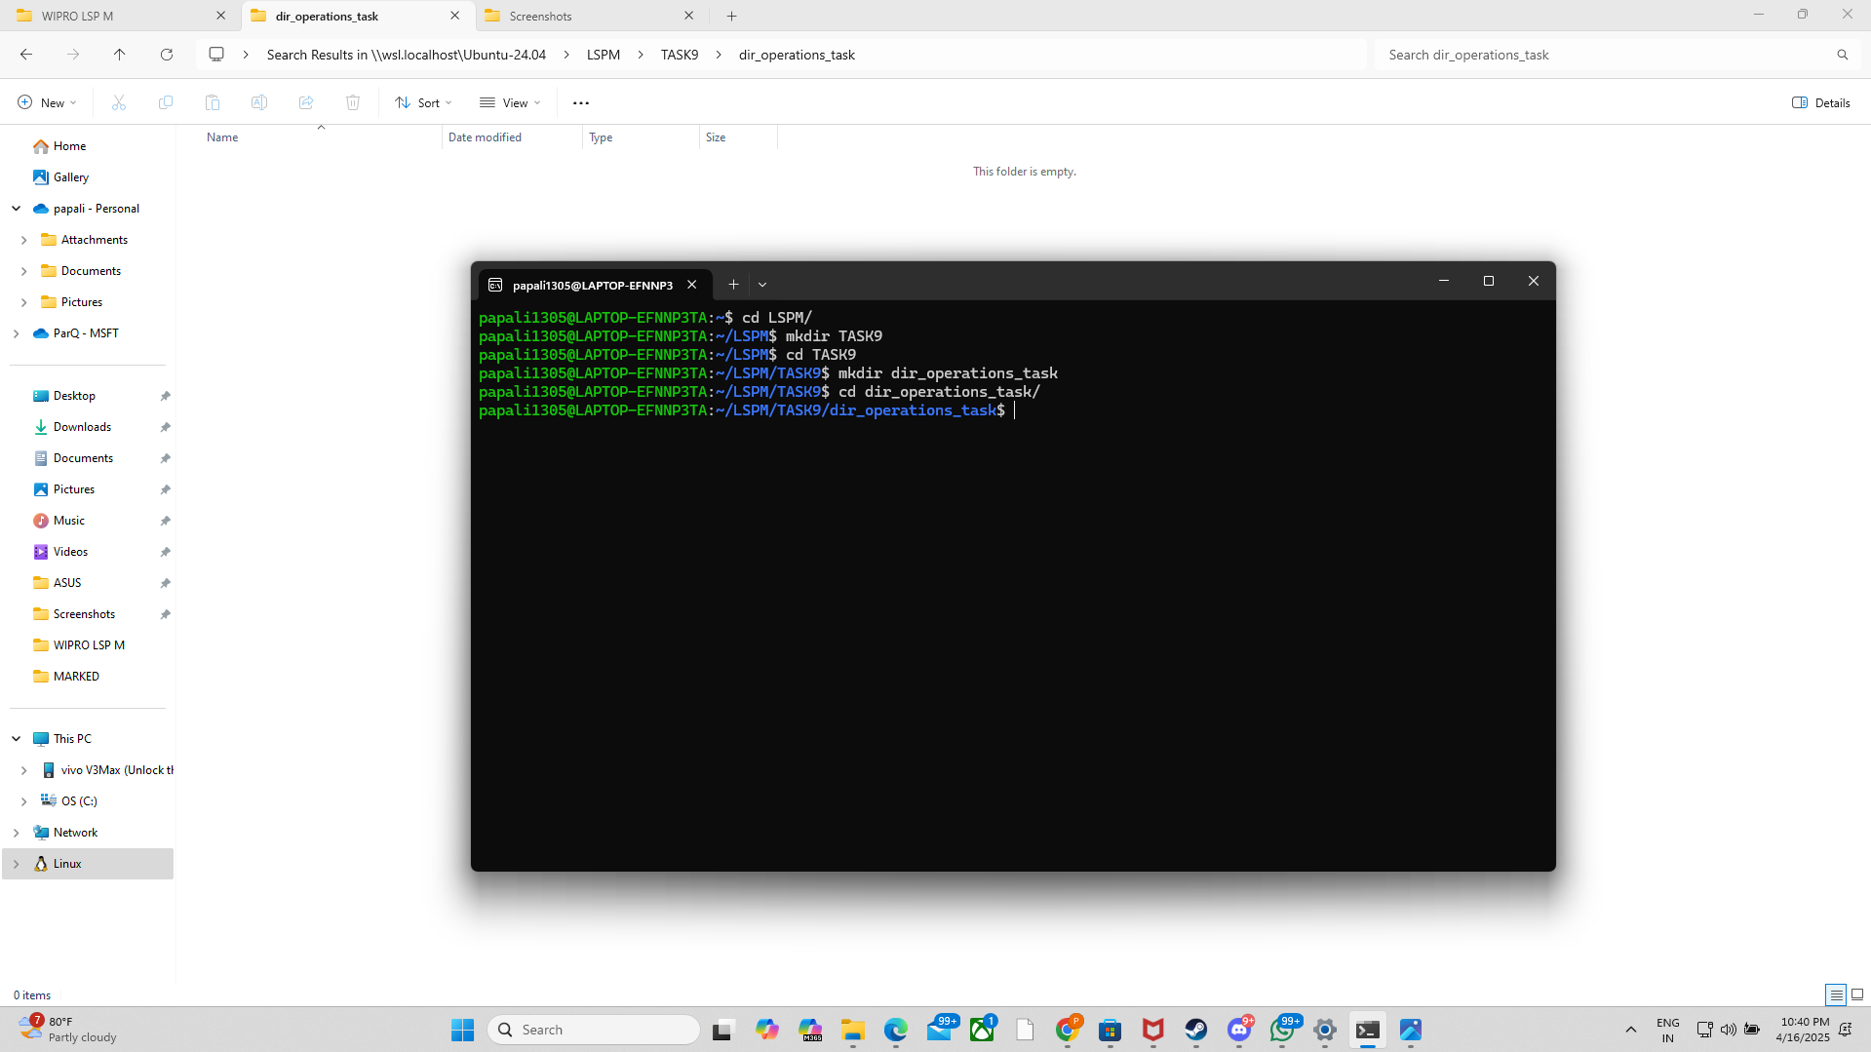

**02).**

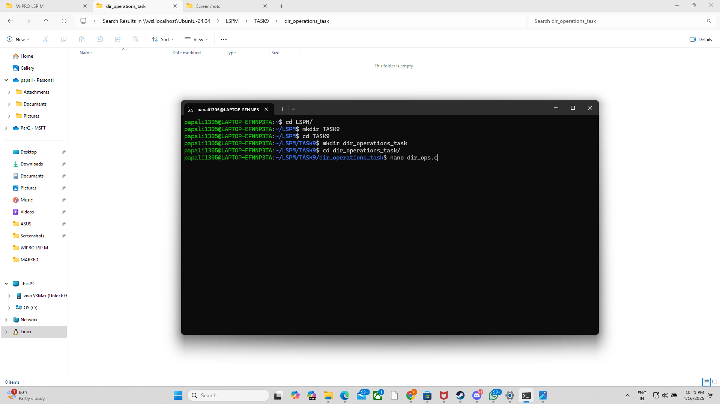

**03).**

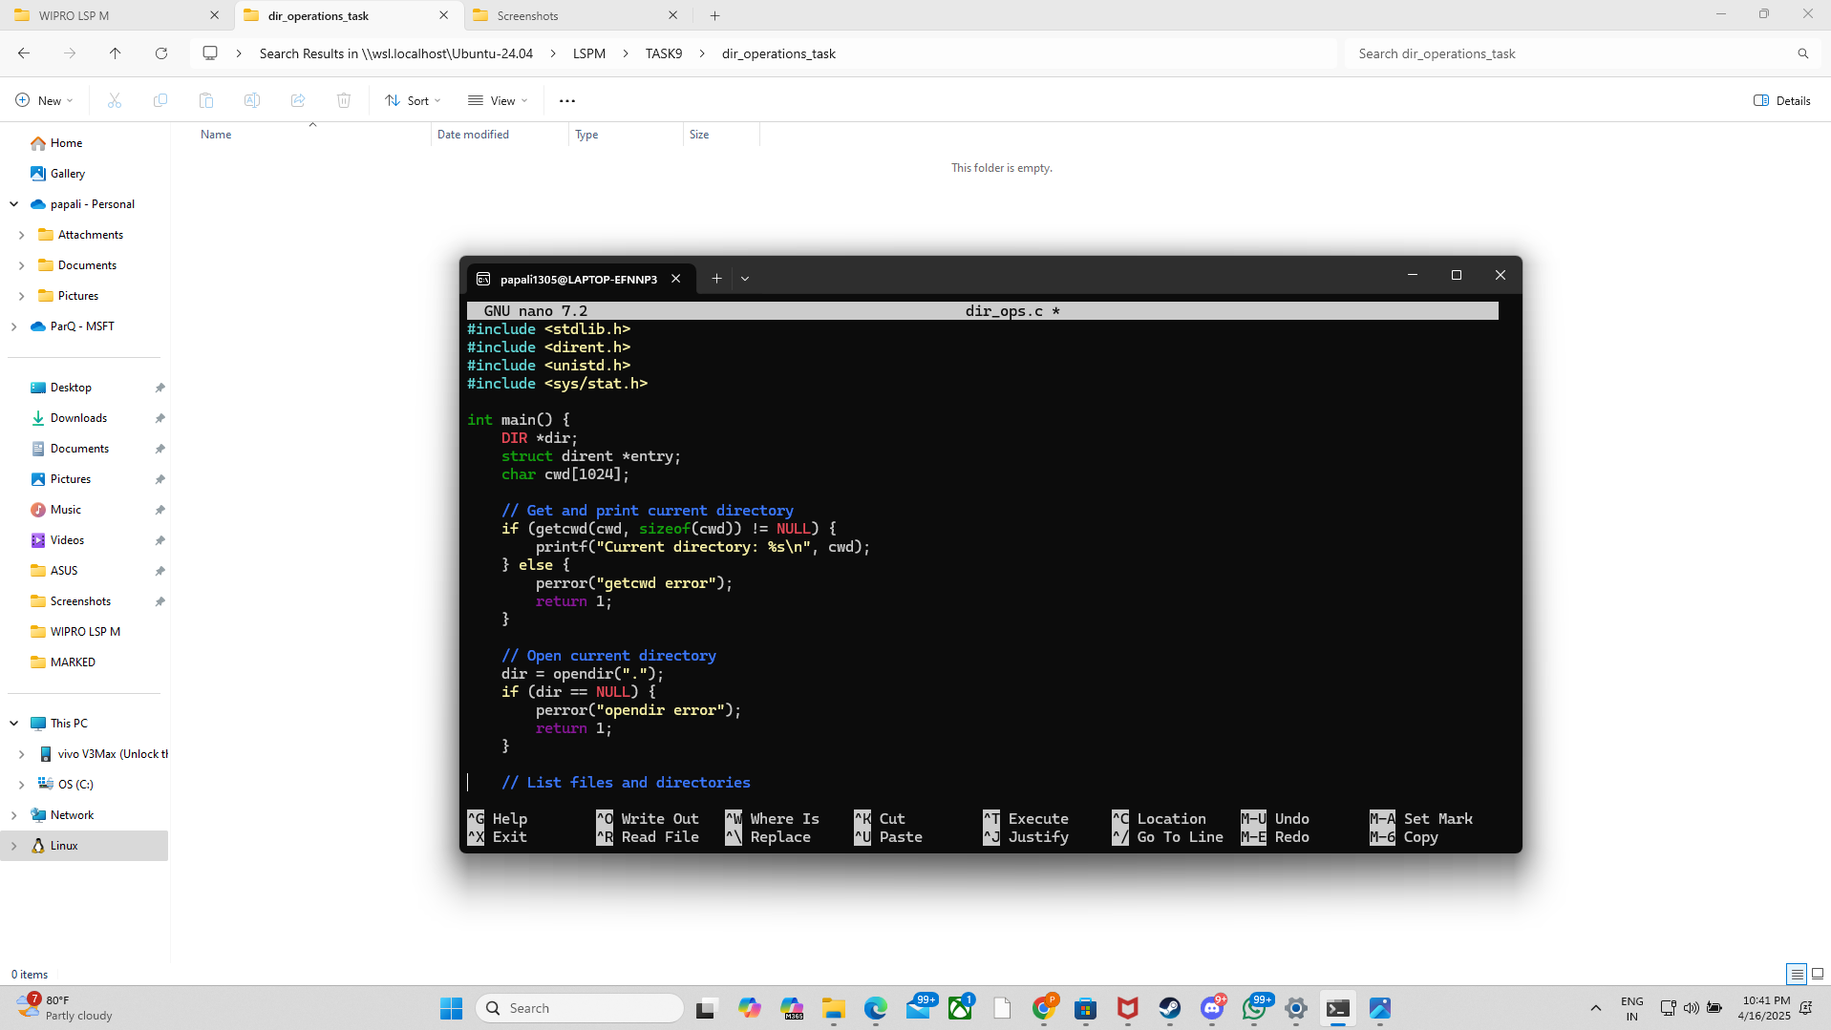

**04).**

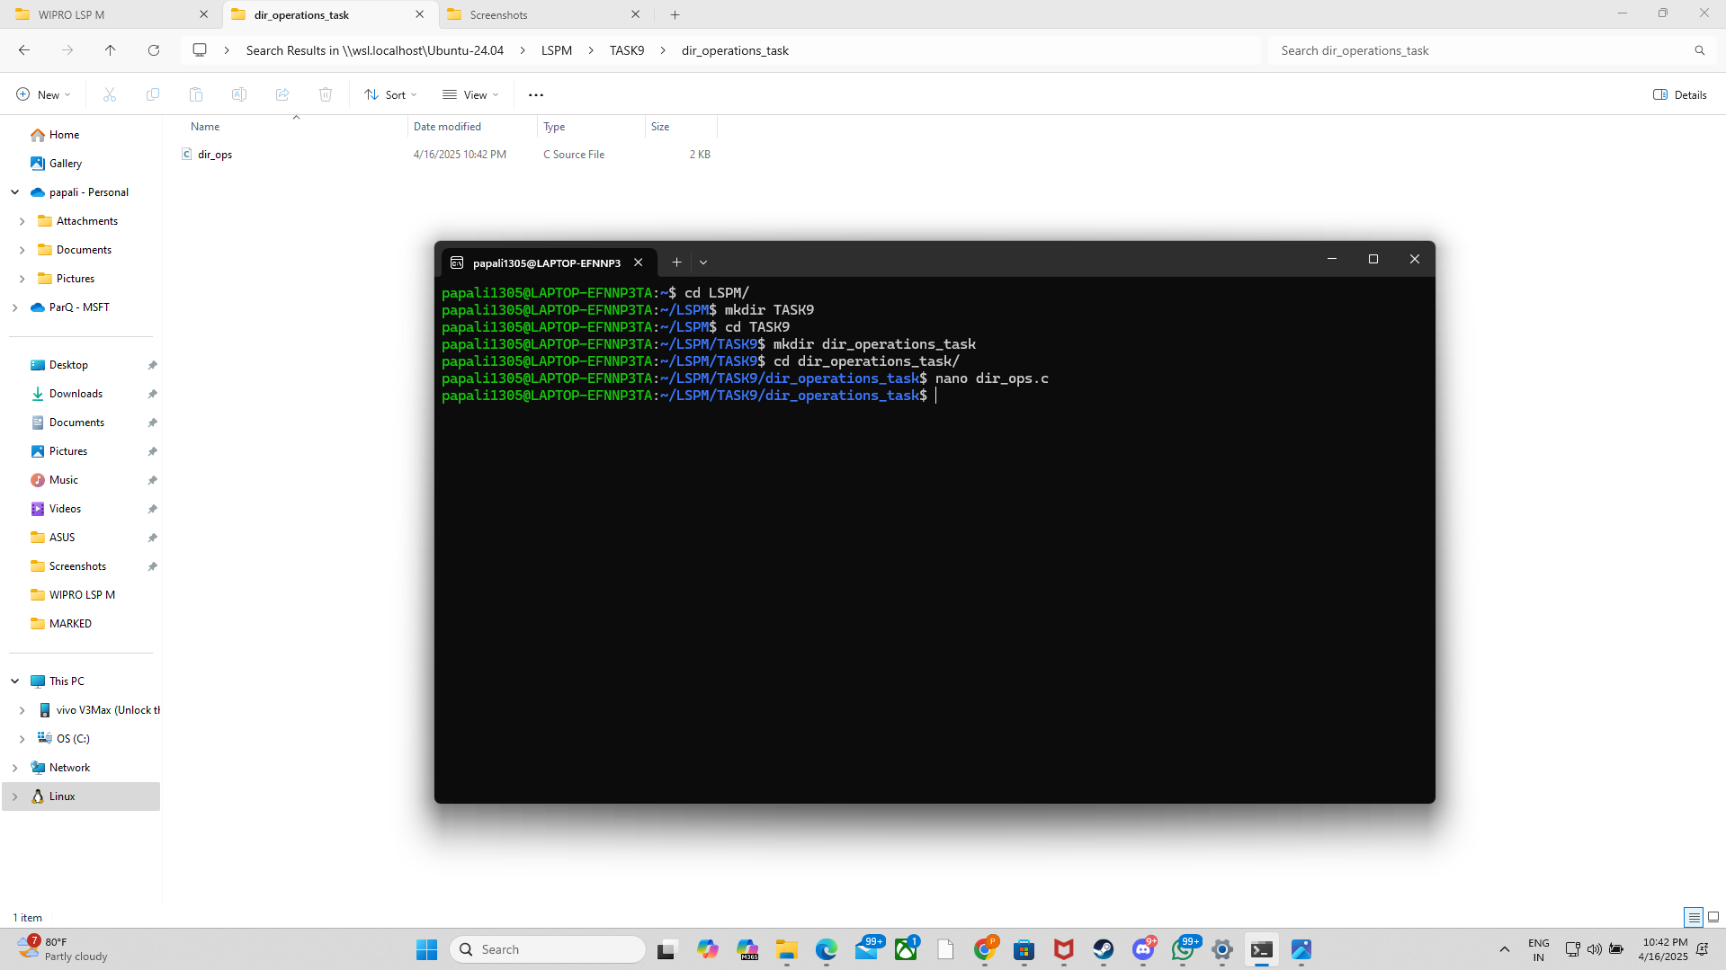

**05).**

